**Q1**. Query all columns for all American cities in the CITY table with populations larger than 100000.

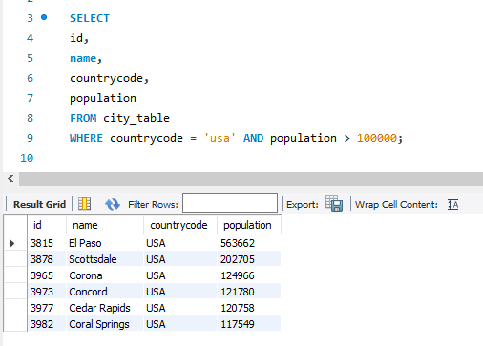

**Q2**. Query the NAME field for all American cities in the CITY table with populations larger than 120000.

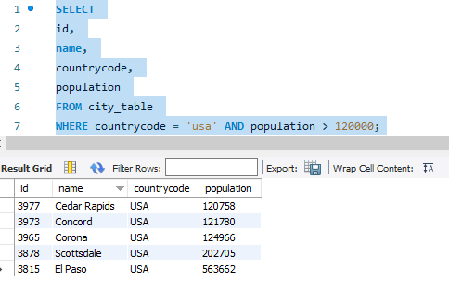

**Q3.** Query all columns (attributes) for every row in the CITY table.

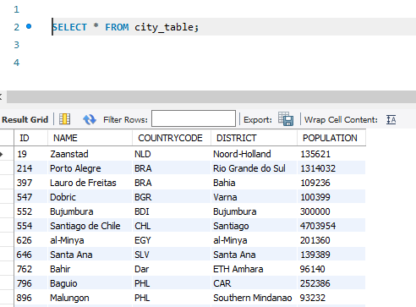

**Q4**. Query all columns for a city in CITY with the ID 1661.

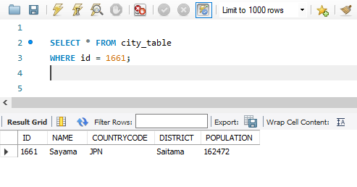

**Q5**. Query all attributes of every Japanese city in the CITY table. The COUNTRYCODE for Japan is

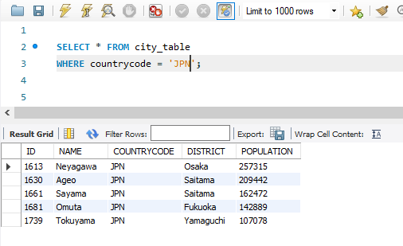

**Q6.** Query the names of all the Japanese cities in the CITY table.

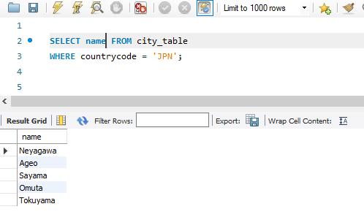

**Q7.** Query a list of CITY and STATE from the STATION table.

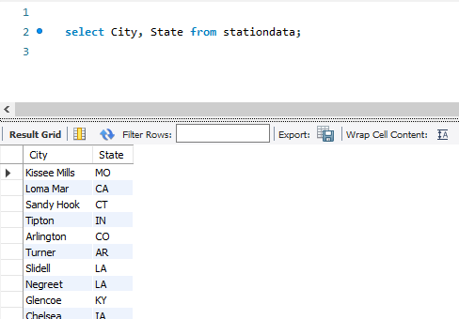

**Q8.** Query a list of CITY names from STATION for cities that have an even ID number. Print the results in any order, but exclude duplicates from the answer.

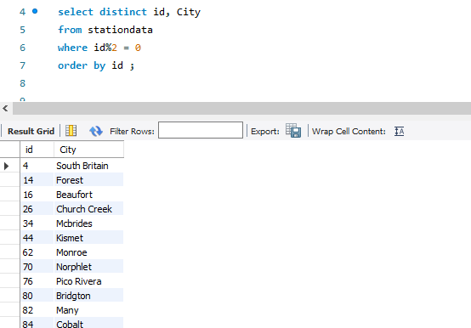

**Q9**. Find the difference between the total number of CITY entries in the table and the number of distinct CITY entries in the table.

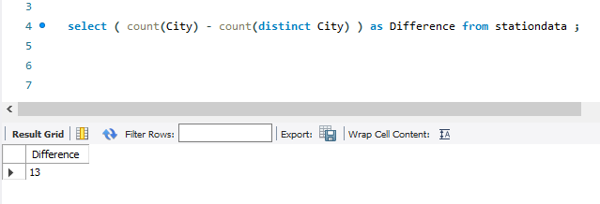

**Q10.** Query the two cities in STATION with the shortest and longest CITY names, as well as their respective lengths (i.e.: number of characters in the name). If there is more than one smallest or largest city, choose the one that comes first when ordered alphabetically.

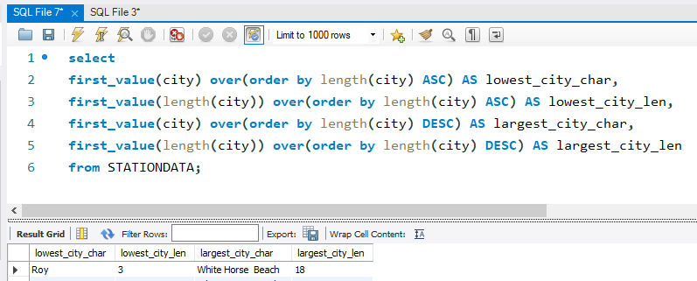

**Q11**. Query the list of CITY names starting with vowels (i.e., a, e, i, o, or u) from STATION.

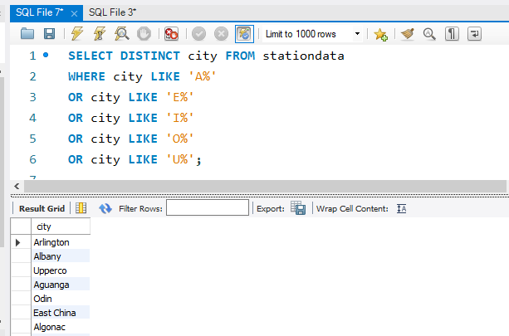

**Q12.** Query the list of CITY names ending with vowels (a, e, i, o, u) from STATION. Your result cannot contain duplicates.

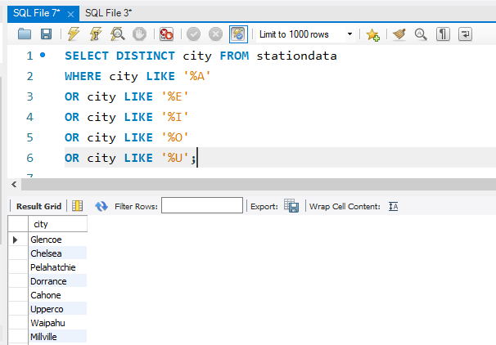

**Q13.** Query the list of CITY names from STATION that do not start with vowels. Your result cannot contain duplicates.

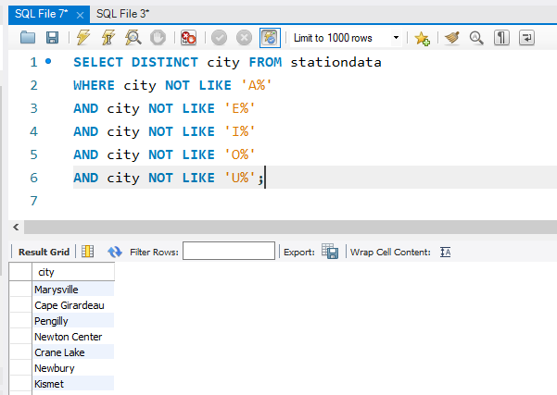

**Q14.** Query the list of CITY names from STATION that do not end with vowels. Your result cannot contain duplicates.

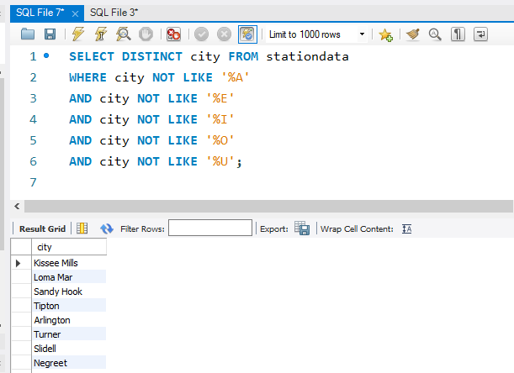

**Q15.** Query the list of CITY names from STATION that either do not start with vowels or do not end with vowels. Your result cannot contain duplicates.

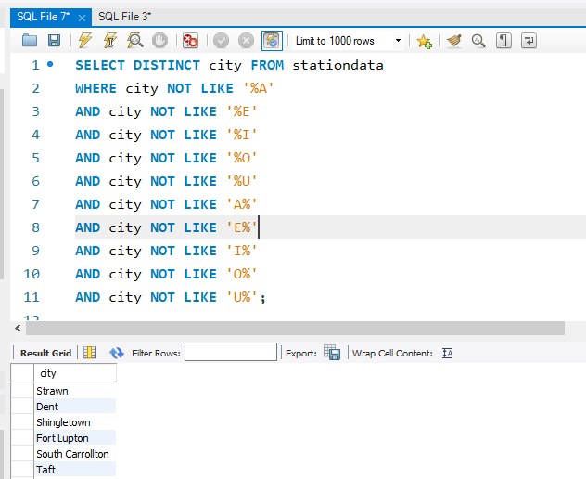

**Q16.** Query the list of CITY names from STATION that do not start with vowels and do not end with vowels. Your result cannot contain duplicates.



**Q.17**

Create table If Not Exists Product (product_id int, product_name varchar(10), unit_price int)

Create table If Not Exists Sales (seller_id int, product_id int, buyer_id int, sale_date date, quantity int, price int)

Truncate table Product

insert into Product (product_id, product_name, unit_price) values ('1', 'S8', '1000')

insert into Product (product_id, product_name, unit_price) values ('2', 'G4', '800')

insert into Product (product_id, product_name, unit_price) values ('3', 'iPhone', '1400')

Truncate table Sales

insert into Sales (seller_id, product_id, buyer_id, sale_date, quantity, price) values ('1', '1', '1', '2019-01-21', '2', '2000')

insert into Sales (seller_id, product_id, buyer_id, sale_date, quantity, price) values ('1', '2', '2', '2019-02-17', '1', '800')

insert into Sales (seller_id, product_id, buyer_id, sale_date, quantity, price) values ('2', '2', '3', '2019-06-02', '1', '800')

insert into Sales (seller_id, product_id, buyer_id, sale_date, quantity, price) values ('3', '3', '4', '2019-05-13', '2', '2800');

**Q.18**

Create table If Not Exists Views (article_id int, author_id int, viewer_id int, view_date date)

Truncate table Views

insert into Views (article_id, author_id, viewer_id, view_date) values ('1', '3', '5', '2019-08-01')

insert into Views (article_id, author_id, viewer_id, view_date) values ('1', '3', '6', '2019-08-02')

insert into Views (article_id, author_id, viewer_id, view_date) values ('2', '7', '7', '2019-08-01')

insert into Views (article_id, author_id, viewer_id, view_date) values ('2', '7', '6', '2019-08-02')

insert into Views (article_id, author_id, viewer_id, view_date) values ('4', '7', '1', '2019-07-22')

insert into Views (article_id, author_id, viewer_id, view_date) values ('3', '4', '4', '2019-07-21')

insert into Views (article_id, author_id, viewer_id, view_date) values ('3', '4', '4', '2019-07-21')

**Q.19**

select round(100*d2.immediate_orders/count(d1.delivery_id), 2) as immediate_percentage

from Delivery d1,

(select count(order_date) as immediate_orders

from Delivery

where (order_date = customer_pref_delivery_date)) d2

**Q.20**

select ad_id,

ifnull(

round(

avg(

case

when action = "Clicked" then 1

when action = "Viewed" then 0

else null

end

) * 100,

2),

0)

as ctr

from Ads

group by ad_id

order by ctr desc, ad_id asc;

**Q.21**

select e.employee_id, (select count(team_id) from Employee where e.team_id = team_id) as team_size

from Employee e

OR

SELECT employee_id, COUNT(team_id) OVER (PARTITION BY team_id) team_size

FROM Employee

**Q.22**

select c.country_name,

(case when (sum(w.weather_state) / count(w.day) )<= 15 then "Cold"

when (sum(w.weather_state) / count(w.day)) >=25 then "Hot"

else "Warm" end ) as weather_type

from countries c

join weather w

on c.country_id = w.country_id

where w.day between '2019-11-01' and '2019-11-30'

group by c.country_id

**Q.23**

select a.product_id, round(

sum(a.price * b.units)/sum(b.units),

2) as average_price

from Prices as a

join UnitsSold as b

on a.product_id = b.product_id and (b.purchase_date between a.start_date and a.end_date)

group by a.product_id;

**Q.24**

create table Activity(player_id int, device_id int, event_date date, games_played int);

insert into Activity values(1,2,'2016-03-01', 5);

insert into Activity values(1,2,'2016-05-02', 6);

insert into Activity values(2,3,'2017-06-25', 1);

insert into Activity values(3,1,'2016-03-02', 0);

insert into Activity values(3,4,'2018-07-03', 5);

create table Result as

SELECT

player_id,

min(event_date) AS first_login

FROM

Activity

GROUP BY player_id;

Select * from Result

**Q.25**

create table Activity(player_id int, device_id int, event_date date, games_played int);

insert into Activity values(1,2,'2016-03-01', 5);

insert into Activity values(1,2,'2016-05-02', 6);

insert into Activity values(2,3,'2017-06-25', 1);

insert into Activity values(3,1,'2016-03-02', 0);

insert into Activity values(3,4,'2018-07-03', 5);

create table Result as

SELECT

player_id,

min(event_date) AS first_login

FROM

Activity

GROUP BY player_id;

**Q.26**

select prod.product_name, prod.unit

from

(select p.product_name,

sum(o.unit) as unit

from Products p

left join Orders o

on p.product_id = o.product_id and

datediff(order_date, '2020=02-01') >= 0 and

datediff('2020-03-01', order_date) > 0

group by p.product_id) prod

where prod.unit >= 100

**Q.27**

select *

from Users

where mail regexp '^[A-Za-z][A-Za-z0-9\_\.\-][*@leetcode\.com$](mailto:*@leetcode\.com$)'

**Q.28**

select customer_id, name

from

(

select o.customer_id, c.name,

sum(case when left(o.order_date,7) = '2020-06' then p.price * o.quantity end) as JuneSpend,

sum(case when left(o.order_date,7) = '2020-07' then p.price * o.quantity end) as JulySpend

from Orders o

left join Customers c on o.customer_id = c.customer_id

left join Product p on o.product_id = p.product_id

group by o.customer_id

having JuneSpend >= 100 and JulySpend >= 100

) as temp

**Q.29**

select distinct title  
from  
(  
 select title  
 from Content c  
 left join TVProgram t  
 on c.content_id = t.content_id  
 where Kids_content = 'Y' and content_type = 'Movies'  
 and date_format(program_date, '%Y-%m') = '2020-06') x

Q.30

select q.id, q.year, ifnull(n.npv,0) as npv

from queries as q

left join npv as n

on (q.id, q.year) = (n.id, n.year)

**Q.31**

select q.id, q.year, ifnull(n.npv,0) as npv

from queries as q

left join npv as n

on (q.id, q.year) = (n.id, n.year)

**Q.32**

SELECT

b.unique_id AS unique_id,

a.name AS name

FROM

Employees a

LEFT JOIN

EmployeeUNI b

ON

a.id = b.id;

**Q.33**

select name, sum(ifnull(distance, 0)) as travelled_distance

from rides r

right join users u

on r.user_id = u.id

group by name

order by 2 desc,1 asc;

**Q.34**

select a.product_name, sum(unit) as unit

from Products a

left join Orders b

on a.product_id = b.product_id

where b.order_date between '2020-02-01' and '2020-02-29'

group by a.product_id

having sum(unit) >= 100

**Q.35**

SELECT user_name AS results FROM

(

SELECT a.name AS user_name, COUNT(*) AS counts FROM Movie_Rating AS b

JOIN Users AS a

on a.user_id = b.user_id

GROUP BY b.user_id

ORDER BY counts DESC, user_name ASC LIMIT 1

) first_query

UNION

SELECT movie_name AS results FROM

(

SELECT c.title AS movie_name, AVG(d.rating) AS rate FROM Movie_Rating AS d

JOIN Movies AS c

on c.movie_id = d.movie_id

WHERE substr(d.created_at, 1, 7) = '2020-02'

GROUP BY d.movie_id

ORDER BY rate DESC, movie_name ASC LIMIT 1

) second_query;

**Q.36**

select name, sum(ifnull(distance, 0)) as travelled_distance

from rides r

right join users u

on r.user_id = u.id

group by name

order by 2 desc,1 asc;

**Q.37**

SELECT

b.unique_id AS unique_id,

a.name AS name

FROM

Employees a

LEFT JOIN

EmployeeUNI b

ON

a.id = b.id;

**Q.38**

select id, name

from Students

where department_id not in (select id from Departments);

**Q.39**

select from_id as person1,to_id as person2,

count(duration) as call_count, sum(duration) as total_duration

from (select *

from Calls

union all

select to_id, from_id, duration

from Calls) t1

where from_id < to_id

group by person1, person2

**Q.40**

select p.product_id,

round(cast(sum(p.price*us.units) as decimal)/sum(us.units),2)

from prices as p, UnitsSold as us

where us.purchase_date between p.start_date and p.end_date

and p.product_id = us.product_id

group by p.product_id

**Q.41**

select name as warehouse_name, sum(units * vol) as volume

from Warehouse w

join (select product_id, Width*Length*Height as vol

from Products) p

on w.product_id = p.product_id

group by name;

**Q.42**

select s.sale_date,

sum(if(s.fruit = 'apples', s.sold_num, -s.sold_num)) as diff

from Sales s

group by s.sale_date;

**Q.43**

create table Activity(player_id int, device_id int, event_date date, games_played int);

insert into Activity values(1,2,'2016-03-01', 5);

insert into Activity values(1,2,'2016-05-02', 6);

insert into Activity values(2,3,'2017-06-25', 1);

insert into Activity values(3,1,'2016-03-02', 0);

insert into Activity values(3,4,'2018-07-03', 5);

create table Result as

SELECT

player_id,

min(event_date) AS first_login

FROM

Activity

GROUP BY player_id;

Select * from Result

**Q.44**

ABLE students

id INTEGER PRIMARY KEY,

firstName VARCHAR(30) NOT NULL,

lastName VARCHAR(30) NOT NULL*/

select count(*)

from students

where firstName = 'John'

**Q.45**

SELECT dept_name, COUNT(student_id) student_number

FROM Department d LEFT JOIN Student s

ON s.dept_id = d.dept_id

GROUP BY d.dept_id

ORDER BY student_number DESC, dept_name;

**Q.46**

create table Customer(customer_id int, product_key int);

insert into Customer(customer_id,product_key)

values

(1,5),

(2,6),

(3,5),

(3,6),

(1,6);

create table Product(product_key int);

insert into Product(product_key)

values

(5),

(6);

select a.customer_id from

(select customer_id, count(distinct product_key) as num

from Customer

group by customer_id) a

where a.num = (select count(distinct product_key) from Product);

**Q.47**

select p.project_id

from Project p

group by p.project_id

having count(p.employee_id) =

(select max(p1.employee_cnt)

from (select project_id, count(employee_id) as employee_cnt

from Project

group by project_id) p1

);

**Q.48**

select book_id, name

from books

where book_id not in (

select book_id

from orders

where (dispatch_date between date_sub('2019-06-23',interval 1 year) and '2019-06-23')

group by (book_id)

having sum(quantity) >= 10)

and

available_from < date_sub('2019-06-23', interval 1 month);

**Q.49**

select e1.student_id, min(e1.course_id) as course_id, e1.grade

from Enrollments e1

where e1.grade =

(select max(grade) as max_grade

from Enrollments e2

where e1.student_id = e2.student_id)

group by e1.student_id

order by e1.student_id;

**Q.50**

select t.team_id, t.team_name,

if null(sum(case when t.team_id = m.host_team and m.host_goals > m.guest_goals then 3

when t.team_id = m.host_team and m.host_goals = m.guest_goals then 1

when t.team_id = m.guest_team and m.host_goals < m.guest_goals then 3

when t.team_id = m.guest_team and m.host_goals = m.guest_goals then 1

else 0 end), 0) as num_points

from Matches m

right join Teams t

on m.host_team = t.team_id or m.guest_team = t.team_id

group by team_id, team_name

order by num_points desc, team_id;